Math 10

Lesson 6-7 Answers

**Lesson Questions**

**Question 1**

The volume consists of a cylinder and half a sphere.



**Question 2**

The area consists of 5 square faces (sides + base) and 4 triangular faces.



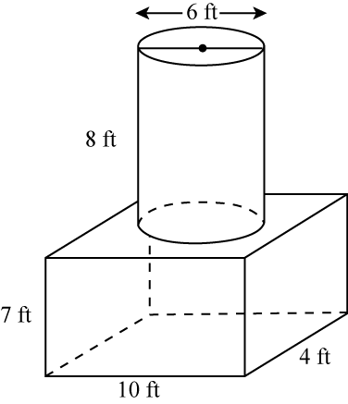**Question 3**

Surface area

The shape consists of the base, top and sides of a rectangular prism. The shape also includes the side of the cylinder. Note that the top of the cylinder is the same as the area that would have to be subtracted from the top of the prism so we do not have to worry about that.



Volume

The volume consists of a rectangular prism and a cylinder.



**Assignment**

1. a) 170 cm2 b) 1040 ft.2 c) 95 in.2 d) 314 in.2

2. a) Object in part c b) Approximately 38 in.3

3. a) 273.3 cm2, 353.4 cm3 b) 12.0 m2 , 2.5 m3

4. a) 5.8 in. b) 6.7 cm

5. a)

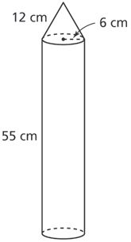

b) 2413 cm2 c) 6612 cm3 d) Approximately 2204 cm3, or 2204 mL

6. a) Circular-based bin b) Square-based bin

7. a) 1300.0 cm3 / 856.2 cm2 b) 6.2 m3 / 24.2 m2

8. a) 1060 in.3 b) 15 in. by 15 in. by 12 in. c) 1820 in.3